MONDAY  NOVEMBER P.O.D. CALENDAR – 3RD GRADE | TUESDAY | WEDNESDAY | THURSDAY | FRIDAY
3  The ant traveled 672 centimeters down the road. The ant took a detour, and it ended up traveling 1,000 cm. How far did the ant travel on its detour? | 4 – TODAY IS ELECTION DAY!  REMIND YOUR PARENTS TO VOTE!!  1,112 people voted at the small voting precinct. 745 of the voters wore buttons to support their candidate choice. How many voters did not wear support buttons? | 5  Franko has $100 to spend on an outfit. He paid $45 for his jeans and $27 for his shirt. How much money does he have left to spend on shoes? | 6  Tanya has $158 and the cost of a bookshelf is $317. About how much more money does she need to buy the bookshelf? | 7  Mr. David buys 329 plastic army men. Mrs. David buys 518 plastic army men. Estimate the sum of the plastic army men.
10  Valerie has collected 987 green marbles. Justin has collected 475 green marbles. About how many more marbles has Valerie collected? | 11  Jolie walked 472 meters. Roy walked 394 meters. Estimate the total distance they walked. | 12  Paula had 72 cards and gave away 59 cards. About how many cards does she have left? | 13  Diana has$99. She saves another $46. About how much money does she have now? | 14  PARENT-TEACHER CONFERENCES ARE TODAY!
17  The sum of 436 and 9,210 is __________. | 18  The difference of 5,060 and 3,668 is __________. | 19  Draw a Base10 representation of the difference of 1,000 and 100. | 20  Draw a Base10 representation of the difference of 1,000 and 990. | 21  Draw a Base10 representation of the sum of 1,000 and 100.
24  The Drama Club has $317 to spend on the next play. Costumes cost $145. Make up costs $102. Estimate the amount of money left after buying the costumes and the make up. | 25  Mr. Hilsap makes 4,276 dinner rolls in a day. Mr. Wu makes 1,530 more dinner rolls than Mr. Hilsap. How many dinner rolls do they make as a team? | 26  VACATION DAY | 27  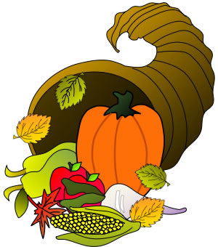  THANKSGIVING DAY | 28  VACATION DAY

