MONDAY  NOVEMBER P.O.D. CALENDAR – 5th GRADE | TUESDAY | WEDNESDAY | THURSDAY | FRIDAY
3  A factory produces 452 beads in 1 minute. Estimate the number of beads the factory produces in 56 minutes? | 4 – TODAY IS ELECTION DAY!  REMIND YOUR PARENTS TO VOTE!!  2,100 people voted at the small voting precinct. 746 of the voters wore buttons to support their candidate choice. 312 of the voters wore T-shirts to support their candidate. About how many voters did not wear buttons or T-shirts to support their candidate? | 5  A museum gift shop sold 1,252 sets of dinosaur models. There were 23 dinosaur models in each set. Estimate the number of dinosaur models the shop sold. | 6  Tanya has $158 and the cost of her favorite book is $18. She plans to give the book to 5 of her friends as gifts. About how much money will she have left after buying the books? Use compatible numbers to help you explain your thinking. | 7  Estimate the quotient of:  1,625 ÷ 4
10  If the cafeteria manager divides 744 chicken nuggets into 6 nuggets per serving, how many servings will she have? | 11  Look back at yesterday’s problem. How many more chicken nuggets will the cafeteria manager need to cook to make 200 servings? | 12  Three archaeologists found 822 bones at the excavation site. They decided to divide the bones equally among them to study. How many bones will each archaeologists study? | 13  Look back at yesterday’s problem. If 3 more archaeologists help to study the bones, how many bones will each archaeologists study? Explain how to use yesterday’s answer to answer today’s question. | 14  PARENT-TEACHER CONFERENCES ARE TODAY!
17  There are 570 boys and 630 girls at the athletic event. Each student participates in one event. Each event has 40 students participating. How many events are there? | 18  Ellen has 900 stamps in her collection. She arranges 25 stamps on each page of a stamp album. The album has 30 pages. How many stamps are left? | 19  96 commuters are on a train. At the next station, 26 commuters get off and 48 commuters get on. How many commuters are on the train now?  Draw a diagram to represent this situation. | 20  A school has 120 fifth-graders who are going by bus on a field trip. Each bus holds 35 students. How many buses are needed?  Draw a diagram to show your thinking. | 21  Rob fills 250-gallon fuel tanks at $3.21 per gallon at a gas station. How much money does he need to pay for filling 2 tanks this size?  Think about how this problem can be solved in more than one way.
24  The Drama Club has $317 to spend on the next play. Costumes cost $145. Make up costs $102. Estimate the amount of money left after buying the costumes and the make up. Use the compatible numbers strategy. | 25  Mr. Hilsap makes 4,276 dinner rolls in a day. Mr. Wu makes 1,530 more dinner rolls than Mr. Hilsap. How many dinner rolls do they make as a team? | 26  VACATION DAY | 27  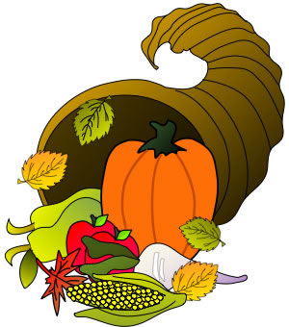  THANKSGIVING DAY | 28  VACATION DAY

