USING MONEY TO MAKE CONNECTIONS BETWEEN FRACTION AND DECIMAL EQUIVALENCIES
*YOU WILL NEED COINS
1. Seat student in groups of 5 at the maximum.
2. Distribute the activity guidelines to each student.
3. Make sure that the students in each group have enough coins for them all to
be able to investigate with a variety of money amounts.
4. Begin by asking students think of coin combinations that equal $1.00.
5. Next, ask students if they can think of ways to make $1.00 using only one
type of coin.

6. Monitor their discussions, encourage students to work together and talk
about the different ways they discover. Challenge them to use each coin.
This discussion will be beneficial when they begin to place the coins into the
fraction spaces.

7. Choose a student who has chosen to use two half-dollar coins to make a
dollar. Have them come to the document camera to show which fraction
spaces (1/2) they can fill using these two coins. Have the students at their
seats fill in their spaces the same way. Have the students mark these spaces
with the value of the money amount ($0.50) that has been placed in the
fraction space. Repeat this investigative sequence until all spaces have been
named with a money (decimal) amount.

*It is important that students share their work and their thought process as
they think through the activity.

* It is also important for the teacher to monitor group activity and discussion
because this will help you to determine which students have clear
understandings that can be shared for the benefit for the whole group.
Created by S. Booker
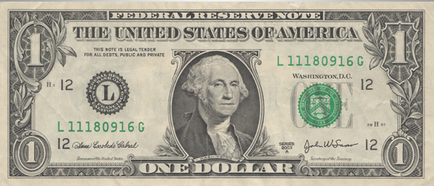
1 whole
$\frac{1}{2}$ $\frac{1}{2}$
$\frac{1}{4}$ $\frac{1}{4 }$ $\frac{1}{4}$ $\frac{1}{4}$
$\frac{1}{8}$ $\frac{1}{8}$ $\frac{1}{8}$ $\frac{1}{8}$ $\frac{1}{8}$ $\frac{1}{8}$ $\frac{1}{8}$ $\frac{1}{8}$
Created by S. Booker
1 whole

$\frac{1}{5}$ $\frac{1}{5}$ $\frac{1}{5}$ $\frac{1}{5}$ $\frac{1}{5}$

$\frac{1}{10}$ $\frac{1}{10}$ $\frac{1}{10}$ $\frac{1}{10}$ $\frac{1}{10}$ $\frac{1}{10}$ $\frac{1}{10}$ $\frac{1}{10}$ $\frac{1}{10}$ $\frac{1}{10}$

Created by S. Booker

Use the information you have collected to help you with the following items.

How much money is equal to one-half of a dollar? __________________________
How much money is equal to one-fourth of a dollar? _____________________
How much money is equal to one-fifth of a dollar? _______________________
How much money is equal to one-tenth of a dollar? _____________________

How much money is equal to three-fourths of a dollar? _________________________
How much money is equal to three-fifths of a dollar? __________________________
How much money is equal to three-eighths of a dollar? _________________________
How much money is equal to three-tenths of a dollar? _________________________

****************************************************************************************
Look at the work you have done to help you answer this question about each amount.
What fraction is equivalent to each money amount?
$0.25 = _________ $0.10 = _________ $0.50 = _________

$0.40 = _________ $0.75 = _________ $0.80 = _________

What pattern do you see occurring between the decimal equivalencies for halves, fourths and eighths? ___________________________________________________________________________________
_______________________________________________________________________________________________________________
What pattern do you see occurring between the decimal equivalencies for fifths and eighths?______________________________________________________________________________________________________________________________________________________________________________________________________________________________
Created by S. Booker

